L2-W2-DBS301-select-range-order

**Due Friday midnight of week 2**

*STEP 1: rename the file to L2-your id name*

*STEP 2: Put the SQL and the results after each question below*

*STEP 3: Email this back before the deadline with subject line L2-yourid and section id*

1 Display the employee_id, last name and salary of employees earning in the range of $8000 to $15,000. Sort the output by top salaries first and then by last name.

SELECT employee_id, last_name, salary

FROM employees

WHERE salary BETWEEN 8000 AND 15000

ORDER BY salary DESC, last_name;

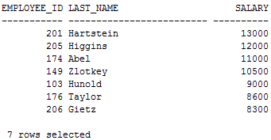

2 Modify previous query (#1) so that additional condition is to display only if they work as Programmers or Sales Representatives. Use same sorting as before.

SELECT employee_id, last_name, salary, job_id

FROM employees

WHERE salary BETWEEN 8000 AND 15000

AND job_id IN('IT_PROG', 'SA_REP')

ORDER BY salary DESC, last_name;

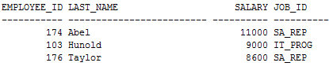

3 The Human Resources department wants to find high salary and low salary employees. Modify previous query (#2) so that it displays the same job titles but for people who earn outside the given salary range from question 1. Use same sorting as before.

SELECT employee_id, last_name, salary, job_id

FROM employees

WHERE (salary < 8000 or salary > 15000)

AND job_id IN('IT_PROG', 'SA_REP')

ORDER BY salary DESC, last_name;

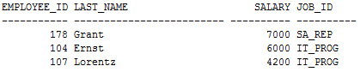

4 The company needs a list of long term employees, in order to give them a thank you dinner. Display the last name, job_id and salary of employees hired before 1998. List the most recently hired employees first.

SELECT last_name, job_id, salary

FROM employees

WHERE hire_date < '01-JAN-98'

ORDER BY hire_date DESC;

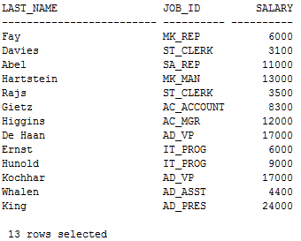

5 Modify previous query (#4) so that it displays only employees earning more than $10,000. List the output by job title alphabetically and then by highest paid employees.

SELECT last_name, job_id, salary

FROM employees

WHERE hire_date < '01-JAN-98'

AND salary > 10000

ORDER BY job_id, salary DESC;

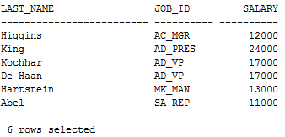

6 Display the job titles and full names of employees whose first name contains an ‘e’ or ‘E’ anywhere. The output should look like:

Job Title Full name

--------------------------------------

AD_VP Neena Kochhar

… more rows

SELECT job_id "Job Title", first_name || ' ' || last_name "Full name"

FROM employees

WHERE first_name LIKE '%e%'

OR first_name LIKE '%E%';

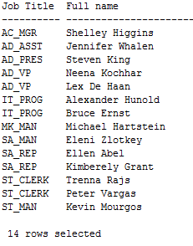

7 Create a report to display last name, salary, and commission percent for all employees that earn a commission.

SELECT last_name, salary, commission_pct

FROM employees

WHERE commission_pct IS NOT NULL;

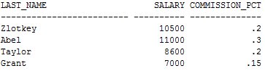

8 Do the same as question 7, but put the report in order of descending salaries.

SELECT last_name, salary, commission_pct

FROM employees

WHERE commission_pct IS NOT NULL

ORDER BY salary DESC;

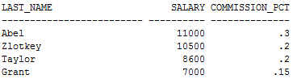

9 Do the same as 8, but use a numeric value instead of a column name to do the sorting.

SELECT last_name, salary, commission_pct

FROM employees

WHERE commission_pct IS NOT NULL

ORDER BY 2 DESC;

